**ASSIGNMENTS 3**

*Assignment on String ,String Buffer, String Builder*

**I] Assignment on String Class**

# 1) String length()

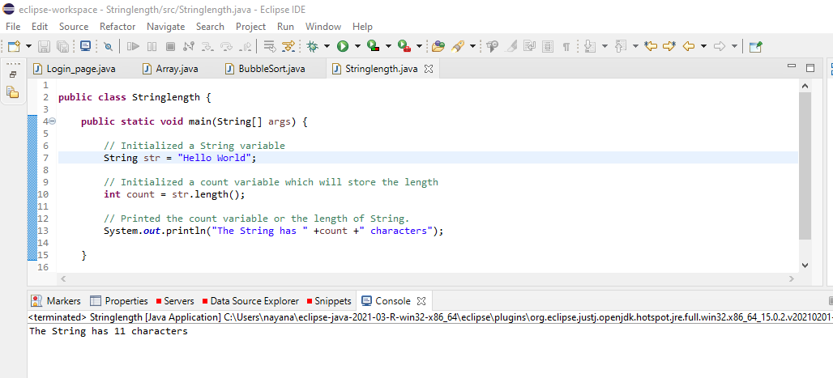

2) String concat()

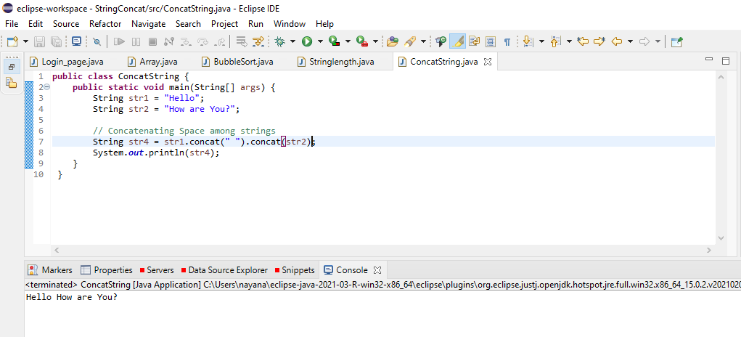

3a) String toLowerCase()

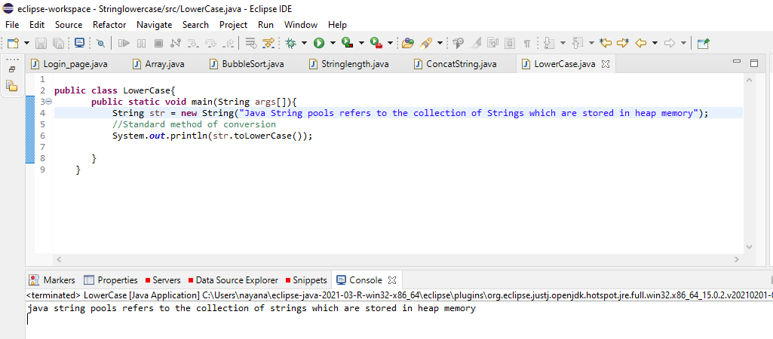

3b) String toUpperCase()

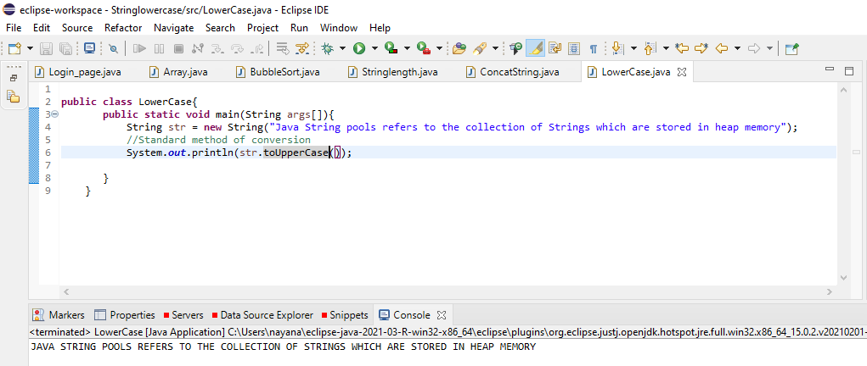

3c) String replace()

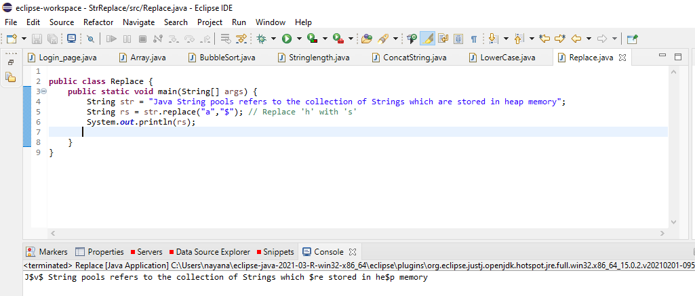

3d) String contains()

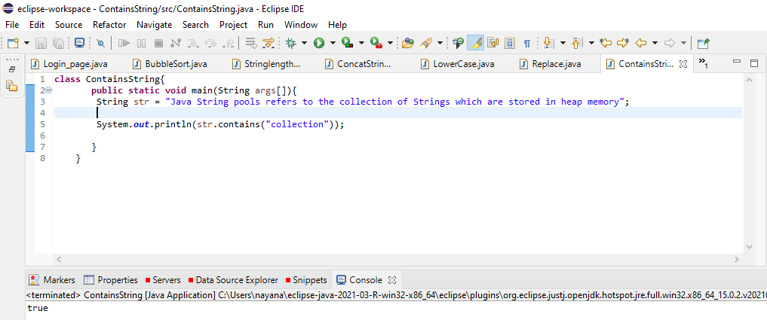

3e) String matches()

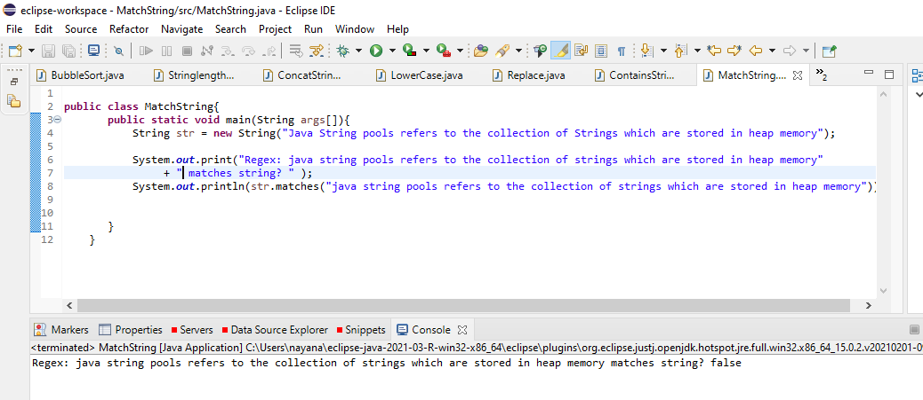

3f) String equals()

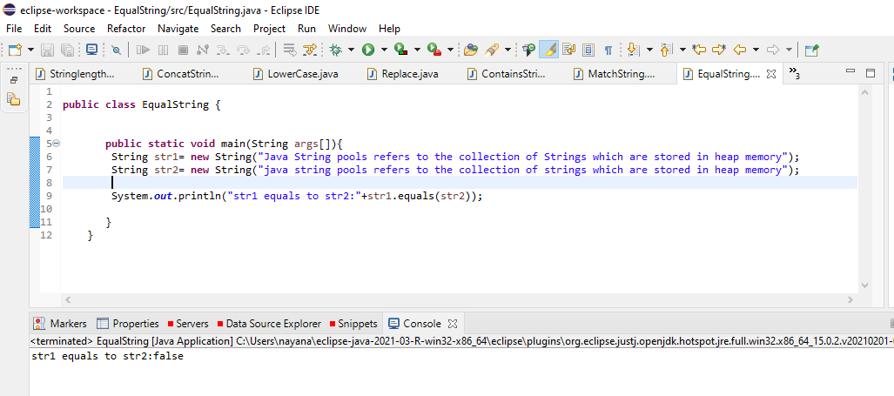

**II] Assignment on StringBuffer Class**

1. StringBuffer append()

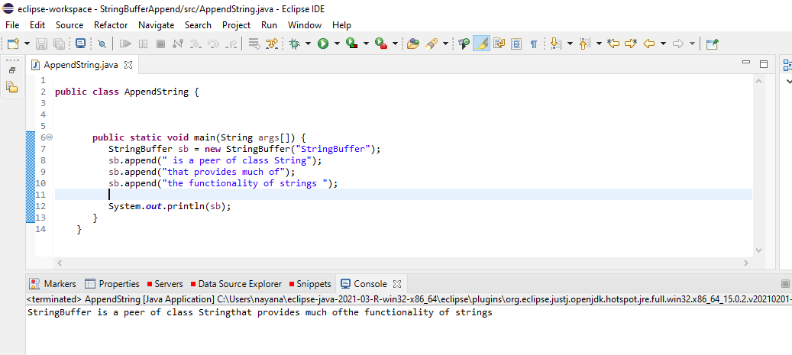

2) StringBuffer insert()

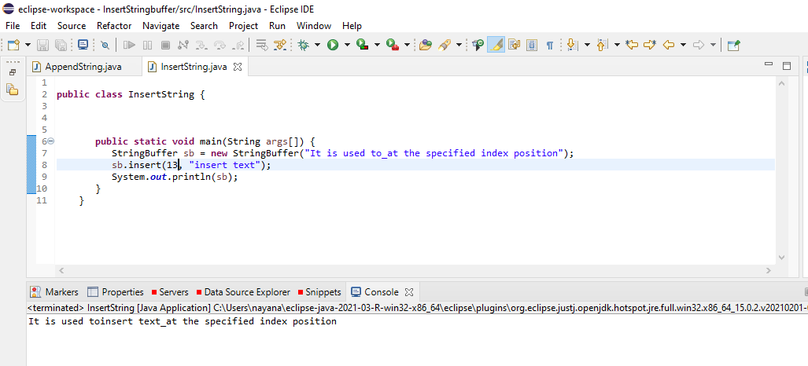

3) StringBuffer reverse()

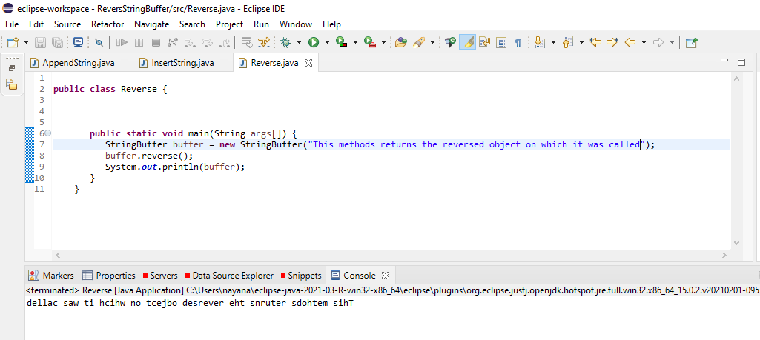

**III]Assignment on StringBuilder class**

1. StringBuilder append()

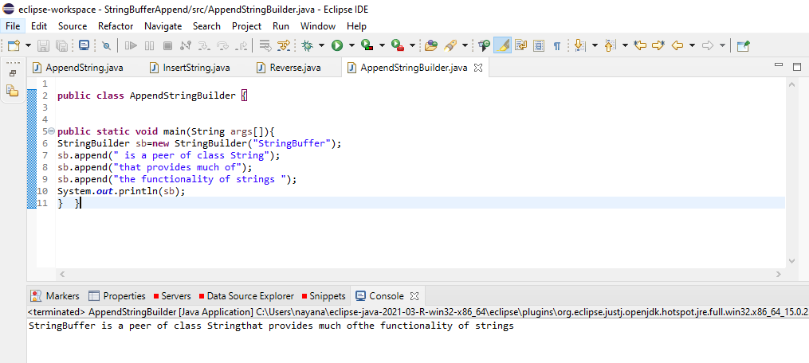

1. StringBuilder insert()

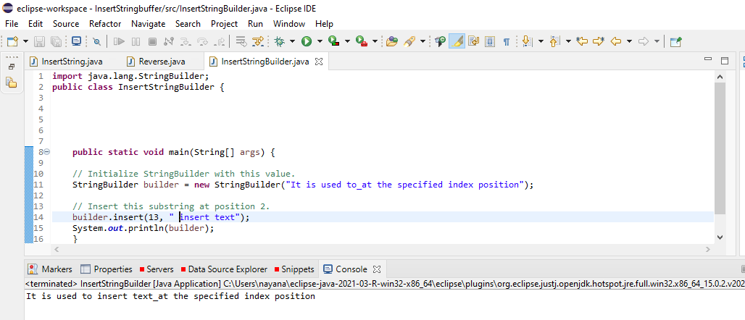

1. String Builder reverse()

